# **Position: Social Media and Communications Intern**

**Job Description:** Field Inclusive is seeking one part time intern to manage our social media presence and communications. This intern will help Field Inclusive with growing demands for our services, partnership, and engagement. This position offers the opportunity to learn and enhance communications and program facilitation skills and experience including program coordination, public speaking and leadership, public education and outreach, administration, communications through various media with diverse audiences, and more. This opportunity will include on-the-job experience with coordinating and organizing social media and other promotional content, facilitating and supporting workshops, conferences and educational events in a supportive environment for a thriving organization that is in the process of scaling up impact and operations. Interns will also enjoy access to networking and educational opportunities through Field Inclusive and Conservation Nation’s partnerships and professional development programs.

**Internship Duration:** February - November 2025

**Salary:** $16/hour, plus a $25/month stipend to offset personal expenses related to remote work

**Sample of Expected Duties:**

* Manage and evaluate Field Inclusive social media platforms (Facebook, Instagram, LinkedIn)
* Manage workshop communications, scheduling, and evaluations
* Write news releases for the Field Inclusive website
* Create a monthly Newsletter
* Assist with partner events and public education events

**Desired Qualifications:**

* Website management (Wordpress)
* Email marketing software experience (Creative Mail)
* Seasoned social media user
* Communications experience
* Event coordinating and outreach experience
* Teaching, mentoring and/or facilitation experience
* (Bonus) Background or concentration in natural resources or empowering marginalized communities.

**Who Should Apply:**

* 3rd and 4th year college students and recent college graduates looking for professional communications experience

*Field Inclusive is an equal opportunity employer dedicated to a culture of inclusion and equity. It is the policy of Field Inclusive not to discriminate against any applicant for employment, or any employee because of age, color, sex, disability, national origin, race, religion, or veteran status.*

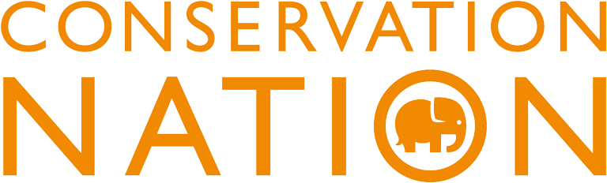

**This internship is funded by the** [**Conservation Nation Chrysalis Fund Internship Program**](https://grants.conservationnation.org/s/funding-program/a11UO000004uiVWYAY/2024-chrysalis-fund-internship-program)**. Conservation Nation Funding Programs provide support to help save animals and their ecosystems by building a stronger, more diverse community of conservation practitioners.**

**Social Media and Communications Internship Application**

**Email completed application and all required application materials to** [**info@fieldinclusive.org**](mailto:info@fieldinclusive.org) **with the subject line “Internship Application” no later than Friday, February 7th 11:59 PM EST.**

**Required Application Materials:**

1. Cover letter
2. Resume
3. Contact information for 1 professional/academic reference and 2 additional references (name, title, organization, phone number, relationship to you)
4. A communications / social media portfolio or writing sample
5. Completed application document

**Application Questions:**

(You may edit this page and type your answers below each question.)

1. Please list your social media handles.
2. What is your experience in social media management and/or public communications?
3. We seek a candidate who is aligned with Field Inclusive’s mission, elevating positive social change, increasing opportunities and improving outcomes for marginalized populations, partner organizations, and professional disciplines and research, particularly those hinging on fieldwork and engagement with natural resources. Provide a statement on your commitment to these goals and highlight any previous work you have done relevant to these goals.
4. What do you seek to gain through this internship and how does this relate to your professional development and future goals?
5. If selected, you will be expected to handle a workload not to exceed 8 hours per week with most work occurring remotely. The internship requires your participation in up to two, three-hour events per month, some online and others in-person, mostly in-state. Infrequent, non-local travel will be at the discretion of the intern and approved costs will be covered. Do your existing commitments, schedule and lifestyle allow you to reasonably meet or exceed these expectations?